EA Summer Training Workshop:
Helping ELL Students Access Content
July 8, 9, & 10, 2008 – 2:30 to 5:30 p.m.

Kapi‘olani Community College
Teacher Preparation Program

Shawn Ford and Veronica Ogata, Facilitators

Wednesday, July 9, 2008
Topic Mns.
Greeting/ Schedule Overview/
Feedback Rating & Comments/
Collect Reflection 10
Group Work: Homework Discussion 10
Homework Reporting 20
Sample Lesson 15
Break (snacks) 10
Session Topic and Introduction –
Maxim 2: Overview of Scaffolding 10
Scaffolding Techniques 10
Sample Materials/ Reflection 25
Break 10
Application of Maxim 2: Scaffolding
Group Work 30
Sharing/ Discussion 20
Wrap-up/ Homework/ Feedback 10
WELCOME!
Welcome to the EA Summer Training Workshops, sponsored by the new Teacher Preparation Program at Kapi‘olani Community College and funded in part by a federal Perkins grant. This workshop series is prepared for in-service Educational Assistants who work with NEP and LEP students in the state’s DOE system. The purpose of the workshop is to provide EAs with additional training in the form of knowledge and strategies that will help them better facilitate and accelerate the language development of the ELL students who they work with regularly.
We hope you enjoy our program and find it useful for your teaching efforts!
In this three-day workshop series, we'll work on strategies for helping ELL students access the content in their mainstream classes. If you attended last summer’s workshops, this is a completely different set of workshops with new information.

By focusing on key language development principles, we'll examine sample content materials from Language Arts, Mathematics, Physical Sciences and Social Sciences at the primary, intermediate and secondary levels, and work to develop useful activities for helping our ELL students access the content.
The goals of the workshop are to develop attendees' individual strategies and to develop a booklet of sample activities created by the workshop attendees for their future reference and use.
These workshops are appropriate for EAs, PTTs, and all content-area teachers at all levels of the DOE who work with ELL students.
During the workshop, please remember to…
- Actively participate and be open to new ideas.
- Complete all group, reflection, and “homework” tasks.
- Stay on task so we can complete the material in each session on time.

Group Roles
At certain times during the workshop, you’ll be asked to delegate the following roles to table members to complete tasks efficiently:
Leader  Responsible for keeping the group on task. Makes sure that all members of the group have an opportunity to participate and learn. | Timekeeper  Responsible for keeping time and making sure that the group finishes the task on time. | Recorder  Writes out results of group activities or important discussion points. Also prepares presentation materials for oral reports. | Reporter  Gives oral responses about the group’s activities or discussions.

Feedback from Tuesday
- Start on time, too many breaks, air conditioning too low - but class was great!
- Facilities warm
- Facilities warm, breaks too long, more time for lecture, thanks for snacks!
- It would be nice to have a 2-hr. class w/ 1 break
- It was too long!!
- Presentations: maybe close curtain due to sunlight glare
- Group discussions: we need more time
- Would like more strategies/ scaffolding activities
- Have student work showing different levels of proficiency
- This workshop is very knowledgeable. It has much to do to help me in my job.
- Today's workshop gave us usable information that we can apply in the classroom.
Group Work: Discussion of Content Selection Homework
In groups at your tables, take 10 minutes to share your homework with your group-mates. Discuss your reasons for choosing your content and your answers to the three reflection questions. After you have talked with each other about your materials, choose one member at your table to give a brief 3-minute report about her/his materials.
For this activity you’ll need a leader, a timekeeper, a recorder, and a reporter.

REPORT
Materials
Context
What specific strategies would you use to help your students understand the passage?
What specific content is necessary to understand the passage?
What language needs will your students have?
Sample Lesson
Materials: Passage 2- “Desert Lions”
Context: 3rd grade, pull-out, NEP students
What specific strategies would you use to help your students understand the passage?
Assessing background knowledge
Building background knowledge
Flash cards: images and vocabulary
Reading aloud
Repetition
Summarization
Production activities: drawing, word and sentence writing, discussion
Feedback
What specific content is necessary to understand the passage?
Wild animals: lions, porcupines, ostriches, antelope
Desert environment: hot, dry, sand, sun, summer
Survival: hunger, thirst, hunting
What language needs will your students have?
Vocabulary: definitions and recognition
Grammar: present-tense verbs
Reading: repetition and word recognition
Pronunciation: Final consonants (deseRT); r-l (Lion); z-dj (deZert)
Writing: vocabulary items and short sentences
The Language Development Process
Instructor

Input Scaffolding Student Output Feedback
(Content) (Assistance) (Understanding) (Production) (Comments)

Development Cycles

Input Scaffolding Understanding

- Scaffolding is necessary for understanding the input.
MAXIM 2: A range of scaffolding strategies is necessary to help our NEP and LEP students access the content.
Scaffolding is the provision of sufficient supports to promote learning when concepts and skills are being first introduced to students. These supports may include: language resources, a warm-up or background-building task, templates or guides, and specific guidance on the development of cognitive and social skills. These supports are gradually removed as students develop autonomous learning strategies, thus promoting their own cognitive, affective and psychomotor learning skills and knowledge. Teachers help the students master a task or a concept by providing support. (explanation adapted from Wikipedia)
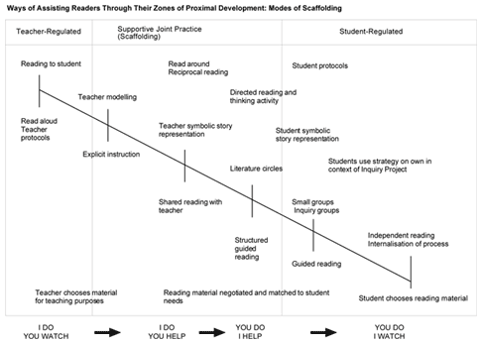
http://www.myread.org/scaffolding.htm
Scaffolding Techniques
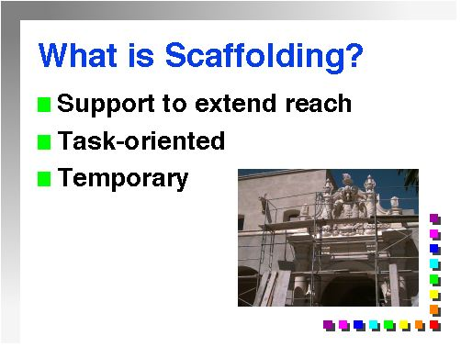
There are generally five different instructional scaffolding techniques: modeling of desired behaviors, offering explanations, inviting student participation, verifying and clarifying student understandings, and inviting students to contribute clues. These techniques may either be integrated or used individually, depending on the material being taught. The instructor’s goal in employing scaffolding techniques is offering just enough assistance to guide the students toward independence and self-regulation.
Scaffolding techniques
- Paraphrasing
- Using “think-alouds”
- Reinforcing contextual definitions
- Procedural scaffolding
  - Teach, model, practice, apply
  - Whole class, Small group, Partners, Independent work
- Instructional scaffolding
  - Questioning
    - Knowledge, comprehension, application, analysis, synthesis, evaluation
    - Reduce linguistic demands of responses while promoting higher levels of thinking
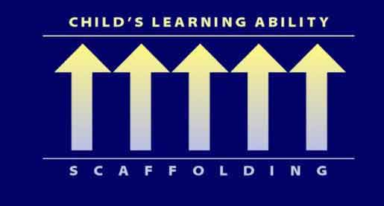
Sample Materials Integrating Scaffolding Techniques
Lesson Plan:
Show students pictures of lions and deserts:

Confirm that they recognize these images. Then give them the vocabulary:
LION DESERT
Alternate between the images and the vocabulary, and ask students to repeat. Work on pronunciation as needed.
Ask students to sketch a picture of a lion in a desert and label the picture.
Show pictures of a hungry lion, water, and a lion hunting:

HUNGRY LION THIRSTY LION HUNT
Alternate between the images and the vocabulary, and ask students to repeat. Work on pronunciation as needed.
Integrate the new words into short sentences: “This is a hungry lion. The lion is hungry.” Ask students to repeat. Work on pronunciation as needed.
Do the same with the desert environment.
Read the passage aloud to the students, pointing to pictures of content while reading.
After reading, ask students to repeat some of the shorter sentences:
“Kalahari lions hunt mostly after the sun has gone down.”
Go back over the passage again, but this time, summarize it simply for the students:
The lion lives in a desert in Africa. The desert is very hot. Life is hard for the lion in the desert. The lion hunts at night, when it is not so hot. The lion eats many animals, like ostriches, porcupines and antelope.
Ask students to explain the story aloud. Provide feedback when needed.
Ask students to draw a simple picture of a lion hunting different animals in the desert and label it, using as many new words as possible. Alternatively, provide students with a simple collage of animals in the desert, and ask students to label it with their new words.
Ask students to write several complete sentences about their pictures.
Ask students to read their sentences aloud.

Group Activity: Scaffolding Reflection
Working with the group at your table, take 5 minutes to discuss which of these scaffolding techniques you already use and which ones you’d like to begin using.

REPORT

Main Group Activity: Application of Maxim 2- Scaffolding
Working with the group at your table, examine the following passage and discuss the different types of scaffolding that you would provide to help your students access the content of the passage. Determine specific content necessary to understand the passage. Predict language needs that your students will have.
Context: Mixed NEP/ LEP students; 7th grade; sheltered instruction learning situation
For this activity you’ll need a leader, a timekeeper, a recorder, and a reporter.

Who Are Today's Immigrants?
1 | Today a new first generation of immigrants is pursuing its dream of a new life in the United States. The backgrounds and experiences of these immigrants are in some ways different from those of the typical European immigrant of the nineteenth and early twentieth centuries Although Europeans are still arriving, the majority of contemporary immigrants come from Asia and Latin America (see Figure 2.1) and include refugees from war-torn parts of the world. In addition, some writers have claimed that a greater proportion of the new immigrants are well-educated, but this claim has been challenged and remains unproven. However, it is clear that many of the better-trained, more prosperous immigrants are not moving into ethnic neighborhoods but instead favor middle-class suburbs. Lastly, the United States of the twenty-first century is no longer expanding its industrial base. Nor is it creating the number of factory jobs that were available for the earlier immigrants.
2 | The differences between modern immigrants and earlier European immigrants cannot be ignored in any thorough analysis of the topic. The differences, however, should not be interpreted to mean that the lives and attitudes of modern immigrants are completely different from those of the Europeans who preceded them. In fact, today's immigrants in many ways are following the patterns that were established by earlier immigrants.
3 | Although some new immigrants live in middle-class suburbs, Asian and Latin ethnic neighborhoods are alive and well in cities across the United States. For many of today's immigrants, these neighborhoods function in the same way as immigrant neighborhoods traditionally functioned for Europeans - as the place to find employment or start a business that serves the ethnic community.
4 | For immigrants who don't live in ethnic neighborhoods, the immigrant community remains an important part of their working and social lives. Although its members may not live near each other the community provides a network of connections and contacts like those in ethnic neighborhoods. Thus, although an ethnic community may not be identified with a specific neighborhood, for the new immigrants, it functions as ethnic neighborhoods have traditionally ------------------------  functioned. It supports them by providing opportunities to socialize and attend religious services with people who know their language and culture. Further, for more recent immigrants wishing to establish businesses, it is a source of both financing and labor. And finally, through the ethnic community, new immigrants can find employers who are willing to hire non-English speakers.
5 | Finally, the new immigrants are also like those of a hundred years ago in their willingness to make sacrifices. In their businesses, they work long hours to compete with economically stronger businesses. Some workers accept jobs of lower status than the jobs they had at home. Some, especially those who open stores in neighborhoods that are populated mainly by other ethnic groups, face the hostility of people who may resent their economic success or their mere presence in the neighborhood. For today's new immigrants, as it was for the generations of Europeans who preceded them, adjusting to life in their new country has its own challenges and hardships.

What specific content is necessary to understand the passage?

What language needs will your students have?

What different types of scaffolding would you provide to help your students access the content of the passage?

REPORT
Wrap-up and Homework Name:
As a follow-up activity, find an appropriate passage that you would use to help develop your students’ content knowledge and language. Make a copy of the passage, provide the context, and answer the following questions. Bring the passage and this sheet on Thursday for group work and to submit for credit.

Context:

What specific content is necessary to understand the passage?

What language needs will your students have?

What different types of scaffolding would you provide to help your students access the content of the passage?

Use the other side of the paper if you need more space to write.
Reflection
Please take 5 minutes to write down your thoughts...
What are your thoughts about this approach to language development?
What are your thoughts about scaffolding for your students?
What will you adapt or adopt for use in your own teaching situation?

Please write this up on another piece of paper as a formal reflection on today’s workshop. Include any other thoughts and comments. Bring it on Wednesday to drop off when you sign in. Thank you! ☺

